US Grade 3 – Pre-test
10 Questions | 30-45 minutes | Calculator not allowed
1. $6×70=a$
What is the value of $a$?
- 420
- 130
- 760
- 52

2. Which fraction is larger than $\frac{2}{3}$?
- $\frac{1}{2}$
- $\frac{4}{6}$
- $\frac{3}{4}$
- $\frac{4}{8}$

3. Neela has three turtles. Each turtle eats 3 ounces of food each day.
Neela has 54 ounces of turtle food.
How many more days can Neela feed her turtles with the food she has?
- 6 days
- 18 days
- 9 days
- 45 days

4. What is 3,457 rounded to the nearest hundred?
- 3,400
- 3,460
- 3,000
- 3,500
5. What time is shown on the clock?
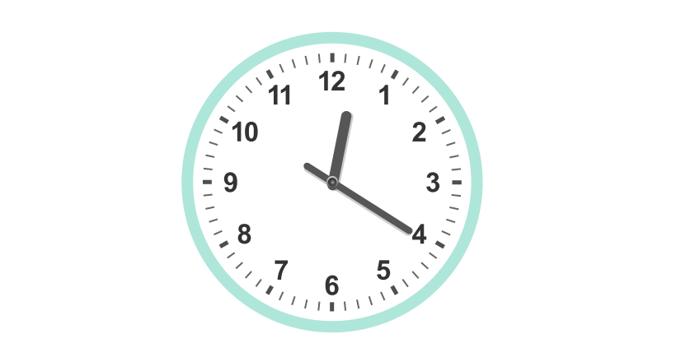
- 12:04
- 12:20
- 1:20
- 1:04

6. Complete the sentence: A quadrilateral and square both always have _______
- equal sides.
- four sides.
- parallel sides.
- right angles.

7. Solve 451 - 268
- 183
- 217
- 293
- 208
8. A pet store has 48 fish. They will be placed into 6 separate tanks. Each tank has the same amount of fish. Which equation can be used to find the number of fish in each tank?
- $48×6=?$
- $48-6=?$
- $48+6=?$
- $48÷6=?$
9. Which shape has an area of 12 units?
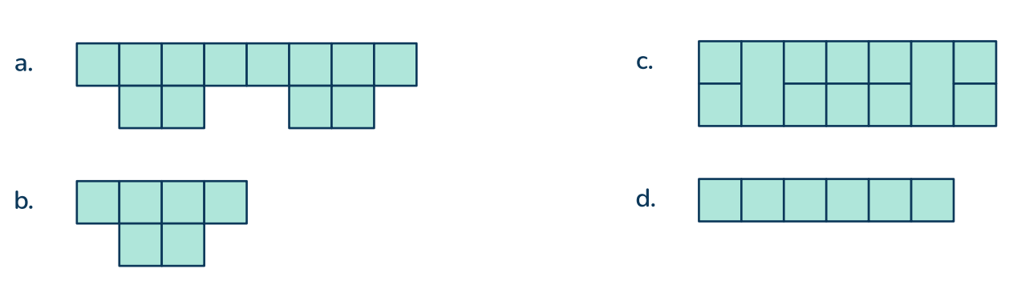
10. Which context can be represent by $42÷7$?
- There were 42 cookies. Then Bryce ate 7 cookies.
- There were 7 cookies and Bryce made 42 more.
- Bryce has 7 bags. He puts 42 cookies equally into the bags.
- Bryce made 42 cookies. He made 7 times as many cookies as Cole.

